Date: Latest Draft | Owner: Preparer of the A3
Approval Date: | Manager Approval:

  BACKGROUND ‘Q1: What are you trying to accomplish?’
  - Why are you talking about it?
  What is the business case? What business problem are you trying to solve or analyze? Be very concise – communicate WHY you are addressing this issue.
  CURRENT CONDITIONS Clarification of the situation to convey meaning to other people
  - What is going on?
  - Use facts, date,
  - Be visual – use Pareto charts, pie charts, sketches
  - Make the problem clear
  GOAL ‘Q2: How will you know that a change is an improvement?’
  State the specific target(s). State in measurable or identifiable terms.
  ANALYSIS Causal Theory: What factors can you manipulate to close the gap between desired state and current state? Causal theory can emerge from problem-analysis or subject matter knowledge or typically a combination. Analysis should lead to change ideas you can test. Root-cause analysis less relevant to new system design problems.
  - Use the simplest problem-analysis tool that will suffice to find the root cause of the problem:
  Five whys; fishbone diagram, problem or process analysis tree, 7 QC tools (old or new), tools
  from the Six Sigma, Kepner-Tregoe, Shainen, Taguchi, TRIZ or other toolbox of your choice.
  PROPOSAL What factors will you modify? In other words, ‘Q3: what change(s) can you make that will lead to improvement?’ Multiple PDSA cycle(s) often needed to build your proposal rather than single ‘one and done’ cycle. Start small to create ‘minimum viable solution’, increase scale and scope to make solution robust. Evaluate actual performance vs predictions at each test cycle. Demonstrate that the proposed change(s) deliver desired performance.
  Your proposed countermeasures
  PLAN for implementation. Reminder from Langley et al. on factors determining readiness for implementation. How strong is your proposal?
  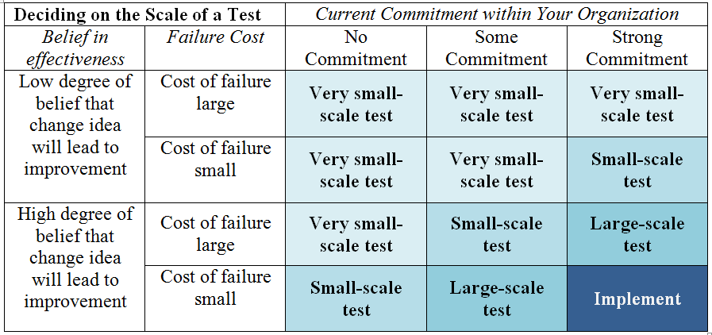
  source: Table 7.1 G. Langley et al. (2009), The Improvement Guide, 2nd edition, Jossey-Bass, San Francisco © Associates in Process Improvement, used with permission.
  Timeline with who, what, when, where, how.
  FOLLOW UP
  - What issues or remaining problems can you anticipate?

